**REGULATION 2026**

**ART 1 - ORGANISING TEAM**

**ART 2 - ACCEPTANCE OF REGULATIONS**

**ART 3 - GENERAL INFORMATION**

**ART 4 - PARTICIPATION**

**ART 5 - FIXED NUMBER REGISTRATION**

**ART 6 - MODE OF REGISTRATION AND DOCUMENTATION**

**ART 7 - REGISTRATION FEE, FINISHER PRIZES**

**ART 8 - RACE DISTANCE CHANGE, REGISTRATION TRANSFER, REFUND**

**ART 9 - SELF-SUFFICIENCY, REFRESHMENT POINT**

**ART 10 - PERSONAL ASSISTANCE**

**ART 11 - OBLIGATORY EQUIPMENT**

**ART 12 - RACE NUMBER AND RACE PACK COLLECTION**

**ART 13 - THE BIB**

**ART 14 - ATHLETE’S BAG DEPOSIT**

**ART 15 - THE ROUTE AND ROUTE MAP**

**ART 16 - MAXIMUM TIME LIMITS AND CUT OFF TIMES**

**ART 17 - CHECKPOINTS**

**ART 18 - SAFETY AND MEDICAL ASSISTANCE**

**ART 19 - AMENDMENTS OF / ON THE ROUTE, RACE CANCELLATION**

**ART 20 - WITHDRAWAL AND RETURNS**

**ART 21 - PENALTIES, DISQUALIFICATION**

**ART 22 - INSURANCE**

**ART 23 - RANKING AND PRIZES**

**ART 24 - RIGHTS OF IMAGE USE**

**ART 25 - DECLARATION OF RESPONSIBILITY**

**ART 26 - TAKING PART IN THE "I DO NOT THROW AWAY MY RUBBISH" CAMPAIGN**

**ART. 1 - ORGANISING TEAM**

Atletica Zoldo - a non-profit making association with headquarters in Val di Zoldo (BL) Italy, in collaboration with Centro Sportivo Italiano (CSI), has officially organised the thirteenth edition of the Trail Running race known as "Dolomiti Extreme Trail", to be held from Friday 12th June to Sunday 14th June 2026.  
The DXT is a partly self-sufficient race on an alpine track environment.

The event offers seven routes:  
• 103K - distance 101 K with D+ 6400 m and D- 6400 m   
• 72K - distance 75 K with D+ 4750 m and D- 4750 m   
• 55K - distance 55 K with D+ 3600 m and D- 3600 m   
• 35K - distance 36 K with D+ 2100 m and D- 2100 m  
• 22K - distance 22 K with D+ 1120 m and D- 1120 m   
• 11K - distance 12 K with D+ 570 m and D- 570 m (competitive and non-competitive)  
• Mini DXT - distance 2,5 K   
Each route must be completed within the specified time limits (see art 16).  
The departure and the arrival are foreseen at Forno di Zoldo for all races (see [program](https://dolomitiextremetrail.com/program.html)).   
The DXT is an eco-compatible race which uses and adapts only existing facilities in the valley with no environmental impact.

**ART. 2 - ACCEPTANCE OF REGULATIONS**

"Dolomiti Extreme Trail" will be held in accordance with these Regulations and any changes and/or directives that will be adopted by the Organising Team, even last minute. Any communications will be published on the website, communicated to all registered or in the relevant notice board at the bib distribution centre.

Entering the "Dolomiti Extreme Trail" means the athletes accept these Regulations in its entirety and without exceptions. On enrolment, each athlete agrees to comply with these regulations and releases the organisers from any civil or criminal responsibility or liability, for any incident or accident, for direct or indirect damage to persons or things that may occur during and after the event.

**ART. 3 - GENERAL INFORMATION**

**3a - 103K, 72K, 55K, 35K, 22K**

The DXT is a running race in a natural environment and in high mountains, winding through high mountain paths and trails, through snowfields, exposed ledges and rocky sections sometimes equipped with ropes: the routes are extremely technical and with testing gradient changes.

The "Dolomiti Extreme Trail" are qualifying races for Ultra Trail Mont Blanc (UTMB World Series QUALIFIER); are evaluated and certified by the International Trail Running Association (ITRA) and assign to the finisher the following points:  
• 103 K: 5 ITRA points  
• 72 K: 4 ITRA points  
• 55 K: 3 ITRA points  
• 35 K: 2 ITRA points  
• 22 K: 1 ITRA point

Furthermore, are part of **ITRA National League** and the **Europe Trail Cup** championship.  
The [**ITRA National League**](https://itra.run/NationalLeague/MoreInfo) ranking is calculated on a country-by-country basis and includes all athletes who have earned ITRA points in at least 3 events in the same country. Participation is automatic by registering for trail running events that are part of the National League circuit.

The [**ETC**](http://alpeadria-trailcup.com/) circuit includes numerous events in various different countries. For each competition, the qualifiers will be assigned a score based on their placement on one of the two existing categories which differ on the basis of the points attributed to the races by ITRA: TRAIL between 1 and 3 points and ULTRA between 4 and 6. In fact, the DXT routes 22K, 35K and 55K are part of the **TRAIL** division, while 72K and 103K of the **ULTRA**. At the end of the championship, the female and male rankings will be drawn up for both categories and the first three classified will receive **a cash prize**.

**3b - 11K**

The “DXT 11K” consists of a NON COMPETITIVE race on foot, in a natural mountain environment, along paths and mule tracks: it is a route that is technical at times and with a challenging altitude difference.

**3c - Mini DXT**

The "Mini DXT" is a recreational race reserved for young athletes. The race with simple obstacles develops for about 2.5 km between meadows and paths.

**ART. 4 - PARTICIPATION**

For safety reasons, it is not permitted to run with dogs on any of the routes.

**4a - 103K, 72K, 55K, 35K, 22K**

The competition is open to everyone aged 18 and over on the date of the race.  
In order to take part, the athletes should have had previous experience in the mountains, must not suffer from vertigo, should have a high standard of athletic preparation, a real ability to be autonomous in order to be able to manage problems created from this type of activity and race.  
It is necessary to wear suitable clothing for the climate (which can vary from -5°C to + 30°C), and to be equipped with the mandatory equipment indicated in Art. 11 of these Regulations.  
Athletes must provide a medical certificate for sporting activities, valid on the date of the race and recognised by the country of residence, irrespective of whether they belong to sports clubs or federations.

To register for the 103K , the athlete must have finished another ultra-trail race in 2024, 2025 or 2026.   
The Organising Team may ask to have access to the curriculum of athletes, to review races run in the recent past in order to compare those indicated on the list, sent to [info@dolomitiextremetrail.com](mailto:info@dolomitiextremetrail.com) asking for such within the date of the closing of the registrations.

**4b - 11K**

The race is open to all people born in 2014 and earlier.  
In addition to having mountain experience, training and the ability to be autonomous enough to manage the difficulties of such a type of test, registration implies the tacit declaration of self-certification of physical fitness to practice non-competitive sports and exempts the organizers from requesting a medical certificate.

It is mandatory to wear suitable clothing for the temperature as well as **shoes suitable for mountain running**.

**4c - Mini DXT**

The race is reserved for girls and boys born 2013 or later. Children under 6 must be accompanied on the route by an adult.

**ART. 5 - FIXED NUMBER REGISTRATION**

Registrations will open on 1st October 2025 for a maximum number of participants which is established as follows:  
• 103K - 500 registrations  
• 72K - 500 registrations  
• 55K - 600 registrations  
• 35K - 600 registrations  
• 22K - 600 registrations  
• 11K - 400 registrations  
• Mini DXT - 300 registrations  
Should there be a higher request than the number of places available, a waiting list shall be created. Any possible increase or decrease of the maximum number of participants will be at the sole discretion of the Organising Team.  
With the exception of the 11K and MINI DXT where one will be able to register up until 13th June 2026, registrations will close by 24th May 2026.  
**Following such date, the Organising team can decide on its own discretion to allow further registrations up on a limited number that will be decided by the Organising team, irrespective of the maximum participations established. In these cases, bibs will not be able to be personalized.**

**ART. 6 - REGISTRATION AND DOCUMENTATION**

Entries must be made online with payment by bank transfer, by credit card or PayPal. A dedicated link is available on [www.dolomitiextremetrail.com](http://www.dolomitiextremetrail.com/).  
The registrations of underage athletes must be made by a parent or someone with parental responsibility.

It is possible to make group registrations: from the dedicated link by selecting: **GROUP REGISTRATION**, the relative instructions will be provided.  
Group registrations entitle you to a discount on registration fees in the order of:  
**5% for groups of 6 to 10 members,  
10% for groups of 11 members and over.**  
It is not necessary for the members of the group to participate in the same race.

The **disclaimer of liability** and the **privacy policy**, visible on the site both from the registration link and from the sections dedicated to competitions, must be read and acceptance will be requested at the time of registration.

The **medical sports certificate** for competitive activity must be uploaded on the website by **07 June 2026**.

On the e-mail confirming registration, you can access the appropriate link to the portal and, following the instructions, send the certificate.

A medical certificate is not required for participation in Mini DXT and 11K.

Any addition to the documentation and the instructions on how to send these through will be published on the website and communicated to all members, and will be considered mandatory.

In the event that the registered competitor does not provide the required documentation when the race numbers are handed out, the athlete will not be able to take part in the race, and will not have the right to any registration fee refund.

Registrations are not accepted at the time of departure.

**ART. 7 - REGISTRATION FEE, FINISHER PRIZE**

Atletica Zoldo is a non-profit sport association made up of voluntary people. The athletes’ registrations fees are contributions made by the participants, to cover organisational costs.

These are not payment for services received.

[REGISTRATION FEES ARE AVAILABLE ON THE WEBSITE.](https://dolomitiextremetrail.com/registration.html)

The enrolment fee includes all services described in these regulations:  
• Personalized Bib + Chip for timing  
• Altitude profile including time limits  
• Personal bracelet that must be work until the end of the race  
• Race pack  
• Finisher medal  
• Timing, intermediate times, rankings online  
• Live-Tracking  
• Pasta party  
• Showers on arrival  
• Collection of athlete’s bag  
• Refreshments during the race and on arrival (see art 5 self-sufficiency)  
• Physio support on Staulanza Pass on arrival  
• Technical, Medical and Health support throughout the race and on arrival  
• Return transport in case of withdrawal  
• Finisher's Certificate service  
• Race event permission  
• Shuttle service in the Valley  
• The FINISHER prize, for those who are eligible to it

The **finisher** **prize** will be given to every athlete that:  
- in the 103K will arrive at least at the Duran Pass time barrier (regardless of the time taken)  
- in the 55K and the 72K will arrive at least at the Staulanza Pass time barrier (regardless of the time taken)  
- in the 35K will arrive at least at the Fusine time barrier (regardless of the time taken)  
- in the 22K will complete the race  
- in the 11K will complete the race.

**ART. 8 - RACE DISTANCE CHANGE, REGISTRATION TRANSFER, REFUND**

A change of registration for a shorter or longer distance (route) is possible. Change of registration for a longer race involves an expense equal to the difference between the registration fee originally paid and the registration fee for the longer route. No refund shall be provided for the change of registration to a shorter race. In both cases there is no administration fee.

It is also possible for members to transfer their registration to another person who has the same necessary requirements to participate (see Article 4). The transfer of registration entails an expense for the applicant of Euro 10.00 as administration fee.

Requests regrding change of distance or transfer of registration must be communicated to the organising team by 24th May.

Where it is not possible to take part in the event, the refund of the registration fee must be requested from the Organising Team as soon as possible.  
In all cases, the following refunds are available:  
• cancellation in October, November and December: reimbursement of 50% of the registration fee (net of bank charges);  
• cancellation in January and February: reimbursement of 40% of the registration fee (net of bank charges);  
• cancellation in March and April: reimbursement of 30% of the registration fee (net of bank charges);  
• cancellation within the 01/05: no reimbursement

The reimbursement of the aforementioned amounts will be made by 31 August.

**Female participants who, between the date of registration and the date of the race, are found to be pregnant may request a full refund of the registration fee, upon submission of a medical certificate confirming the pregnancy.**

**In all cases, the requests must be communicated to the organization by e-mail** [**i**](mailto:info@dolomitiextremetrail.com)**scrizioni-dxt@sportdolomiti.it**

**In no case may the registration fee may be postponed to participation in a later edition of the DXT.**

**ART. 9 - SELF-SUFFICIENCY, REFRESHMENT POINT**

The competition takes place in semi-self-sufficiency.This implies the ability of athletes to be autonomous between two refreshment points, both in terms of food and equipment and safety and being able to adapt in the event of any problems encountered or foreseeable such as, for example, adverse weather conditions, injuries , etc..

However, refreshment points are positioned along the route providing liquids and/or solids:   
• about n. 13 refreshment points in 103K;   
• about n. 9 refreshment points in 72K;   
• about n. 7 refreshment points in 55K;  
• about n. 4 refreshment points in 35K;   
• about n. 3 refreshment points in 22K;  
• about n. 2 refreshment points in 11K.

For each race, the "Timetable / refreshment gates" form will be published on the website, highlighting the refreshment and rescue stations. Any changes will be displayed on a special information board at the bib distribution centre.  
Only the athletes carrying a well visible race number can access refreshment stations.  
Plastic cups will not be available for drinking at the refreshment points. Competitors must be in possession of a cup or other container suitable for personal use.

At the departure from the refreshment points, athletes will only be provided with water, while food and drinks must be consumed on site. Therefore the runners must have in their equipment a supply of food (gel, bars or other foods) able to meet the needs that may exist between the refreshment points. This general rule is to be considered binding for 103K, 72K, 55K and 35K.  
Each runner must ensure that they carry the minimum amount of water expected as compulsory equipment on departure from each refreshment point (see Article 11).

**ART. 10 - PERSONAL ASSISTANCE**

Personal assistance to athletes by people unrelated to the organization is only possible in those refreshment points where the time gates relating to the chosen distance have been programmed (see the characteristics table of each race).

The assistance is allowed to only one person per athlete, without bulky equipment and in respect of others.  
In the event that, within the refreshment area, there is an area used for a specific purpose, the other part of the refreshment will be reserved for competitors only.  
Any indications from the refreshment point manager must be respected with diligence and courtesy.

Personal assistance is forbidden outside the foreseen points.

It is forbidden to be accompanied on the route by another person who is not duly registered.

**ART. 11 - EQUIPMENT REQUIRED**

On registration, each athlete underwrites a commitment to carry all the mandatory equipment listed below throughout the race. If such is not done, the athlete will be disqualified.

The compulsory material will be checked at the time of bib collection, either in full or by sample.   
**Further checks may be carried out at the start of the race, at the arrival and at random locations along the route. It is obligatory to undergo these checks with full cooperation**.

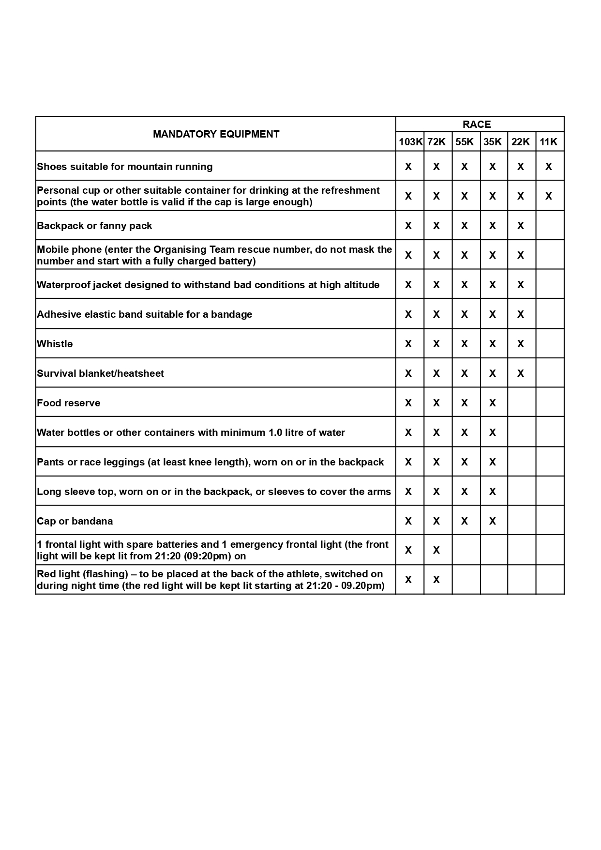

**ART. 12 - RACE NUMBER AND RACE PACK COLLECTION**

Parking areas for registered athletes are visible on the map [DXT Race Logistics](https://www.dolomitiextremetrail.com/program.html).

The race number and race pack collection procedure and checking of the compulsory gear will take place at the DXT Village in Forno di Zoldo only at the scheduled times and published on the website in the [program section](https://www.dolomitiextremetrail.com/program.html).  
The bib collection must necessarily be carried out personally by the registered athlete without any possibility of delegation.

On picking up the bib:  
• each bib will be delivered upon presentation of an IDENTITY DOCUMENT WITH PHOTO;  
• participants shall present the entry confirmation letter received by e-mail, either printed or displayed on a mobile phone

• the COMPULSORY EQUIPMENT of each athlete will be checked;  
• a tag will be tied to the sack confirming that it has been controlled, **only this sack will then be allowed to be used for the race**;  
• each athlete will be given a bracelet to wear until the end of the race;  
• the race packet will be delivered which will contain material provided by the sponsors.

**ART. 13 - THE BIB**

The race number must be worn on the chest or the lower abdomen and be visible in its entirety for the full duration of the race. It should therefore be positioned over any clothing and in no case attached elsewhere.

**Emergency telephone numbers are printed on the race number, as well as the voucher to take advantage of the pasta-party and the voucher for the collection of the finisher prize and acts as the pass necessary to access all services.**

In the event that the altitudes are printed on the bib, these must be considered as purely indicative as for each race route variants or other changes can be applied after the bibs have been printed.

**ART. 14 - ATHLETE’S BAG DEPOSIT**

For all races, with the exception of the Mini DXT, in addition to the showers service upon arrival, the storage and delivery service of the bags with the change of clothes for after the race is provided.

Once the race number is collected, each competitor will be given a bag in which to place clothing for the end of the race and a sticker printed with their race number. The bag can then be handed in to the race number distribution stand until 6:00 PM or before departure directly in the area intended for the collection of the bags by the athletes which will be located near the showers ([see opening hours and village map here](https://www.dolomitiextremetrail.com/en/program)).

**For the 103K, a red bag will also be provided for a possible change of clothes to be picked up at approximately the 54 km life-base of Passo Staulanza. The appropriate sticker bearing the race number and the wording "half race" must be stuck on. We kindly ask you to ensure that your bags are labelled correctly to avoid inconveniences during the race**. Materials left at Life-Base will be available to be collected at the arrival area; in case such material is collected directly at Passo Staulanza by support staff or the registered athlete further to race withdrawal, and therefore the Organising team cannot and is not responsible any longer for transporting the material to the arrival area, **this much be communicated to the person/S responsabile in that area.**

Only bags provided by the organization, suitably marked and without objects attached externally will be managed. All bags will be returned only upon presentation of the race number. It is advised not to leave fragile or valuable items in the bags. The Organizing Team does not accept any responsibility for items lost or damaged during transport.  
Any requests for bags not collected or lost items must be made by writing to [info@dolomitiextremetrail.com](mailto:info@dolomitiextremetrail.com) within 30th June, otherwise these will be destroyed. The Organising team will not be available to organise deliveries of such items.

**ART. 15 - THE ROUTE AND ROUTE MAP**

The "Dolomiti Extreme Trail" races 103K, 72K & 55K have been classified as "EE": itinerary for experienced hikers.  
These are very technical terrains with important gradient changes. These are routes that requires the ability to move on special terrain, inaccessible or treacherous tracks and trails (slopes with rocky outcrops or rubble or snowy tracks), with few markings, with exposed areas and/or protected by fixed ropes.

Competitors of every race must strictly adhere to the marked racecourse by not taking shortcuts or cutting parts of the route. Aside from resulting in disqualification on arrival, departing from the official route shall be at the sole risk and danger of the competitor.

The most updated edition of the topographic map of the route and the gradients along the same route, will be published on the event website.

Unlike the other races, the Mini DXT does not include a topographic map and the route will be indicated only by marking.

**ART. 16 - MAXIMUM TIME LIMITS AND CUT OFF TIMES**

The maximum time allowed to reach the finish line is fixed at:  
• 103K - 30:00 hours;  
• 72K - 21:00 hours;  
• 55K - 15:00 hours;  
• 35K - 8:00 hours;  
• 22K - 4 hours;  
• 11K - 4 hours;  
• Mini DXT - 3 hours

The cut-off time for departure (time barriers) from the main checkpoints will be defined and described on the web-site in the table titled as “CHARACTERISTICS” and in the forms “TIMETABLE / REFRESHMENT GATES”. These barriers are calculated to allow participants to reach the finish line in the maximum time imposed, while making any necessary stops (rest, meals,).  
In order to continue the event, athletes must leave the checkpoint before the cut-off time set. If not done, the athlete will be disqualified and their race number will be withdrawn.

The athlete wishing to continue without a race number, out of the race, will assume all responsibility for any consequences.

**ART. 17 - CHECKPOINTS**

Before the start of the race, each athlete must pass through the entrance gates to the enclosed starting area to be registered. Time and other athlete recordings, both chip or manual, is carried out at the checkpoints.

The main checkpoints are located at the time gates. Runners must ensure that they have been duly registered, when passing the time gates and at the finish. The punching of the bib is indispensable, as a comparison between the two successive checkpoints ensures that there are no missing competitors.  
In the case of failure to register, should there be a search for an athlete, any costs arising will be charged to the athlete himself.  
To avoid coming off the official route, some additional "spot" checkpoints chaired by race stewarts will be positioned between the time gates and refreshment points. Their location shall not be communicated by the Organising Team.

**ART. 18 - SAFETY AND MEDICAL ASSISTANCE**

A rescue callout station will be located at the most significant points as identified by the Organising Team and at the refreshment stations. Ambulances, Civil Protection members and medical staff will be present on route.  
The rescue callout stations are intended to provide assistance to all persons in danger using the Organising Team’s means or through affiliated Organising Teams.  
The official medical staff is authorised to suspend the athletes judged unfit to continue the race. Rescuers are allowed to evacuate, with all the means at their convenience, athletes judged in danger.

If necessary, and in the interests of the persons rescued, solely at the discretion of the Organising Team, the official alpine rescue service shall be called. If so done, they will take over the direction of operations and put in place all appropriate required action, including a helicopter service.  
Any costs arising from use of these exceptional service will be borne by the rescued person in accordance with regulations.

An athlete, who requests assistance to a doctor or a rescuer, submits himself to his/her authority and undertakes to comply with his/her decisions.

**ART. 19 - AMENDMENTS OF / ON THE ROUTE - RACE CANCELLATION**

The Organizing Team reserves the right to modify at any time the route or positioning of the rescue team and refreshment points, the cancellation time, as well as their expiration, by posting any changes on the appropriate bulletin board at the bib collection centre.  
The Race Directors may decide unquestionably to apply VARIANTS to the route (see map on the site) and the official communication of the final route will be given during the general technical briefing (see Program).

In the event of adverse weather conditions (fog, blizzards, storms), in order to not endanger the safety of the competitors, the start of the race may be postponed or canceled. The route may be changed and reduced, or the race may be stopped or suspended at any time and at any point on the track.

The Organizing Team reserves the right to postpone or cancel the race in the event of health provisions issued by national or local institutions that prevent it from taking place.

Race competitors shall not be entitled to any entry fee refund in the case of suspension, postponement or cancellation of the race.

**ART. 20 - WITHDRAWAL AND RETURNS**

In case of withdrawal from the race along the route, the competitor is obliged, when possible, to go to the nearest checkpoint and communicate and record their withdrawal to the race commissioner, by canceling the bib chip and, at distances where its use is provided, handing in the race tracking device.

The Organising Team will be responsible for taking him/her back to the finish area from the points where this service is provided (see the altimetry on the race page).  
In case of failure to notify a withdrawal and the subsequent search for a racer, any costs arising will be charged to the participant himself.

**ART. 21 - PENALTIES AND DISQUALIFICATION**

Controllers on route are authorised to check the mandatory equipment, and in general, monitor that Regulations are being adhered to at any time. All competitors found not in possession of even a single element of the mandatory equipment will be immediately disqualified, without any possibility to appeal.  
Infringements noticed by the Organising Team through video images after the race, may result in disqualification.

The directors of the race may disqualify a competitor in the event of a major violation of the Regulation, in particular:  
• race number bib worn in a non-conforming manner,  
• racing bin not exposed or positioned correctly,  
• exchange of race numbers bibs,  
• failure to pass a checkpoint,  
• absence in part or of all the mandatory equipment,  
• using transport during the race,  
• departure from a checkpoint after the cut-off time,  
• doping or refusal to submit to a doping control,  
• failing to aid another competitor in the event of difficulty,  
• the use of personal assistance outside the points allowed,   
• failure to comply with the ban to be accompanied on the route,  
• abandoning rubbish along the race route, abandonment of personal equipment along the route,  
• pollution or degradation by a competitor or a member of his staff,  
• insults, rudeness or threats towards organisation members or volunteers,  
• refusal to be examined by a doctor of the Organising Team at any time of the race.

Respect yourself: no cheating neither before, nor during the race,  
Respect other athletes; provide support to athletes in trouble.  
Respect volunteers: volunteers also participate for the pleasure of being present.

**ART. 22 - INSURANCE**

The Organising Team subscribe a liability insurance for the duration of the race.

Participation is under the full responsibility of the athletes, who renounce all recourse against the Organising Team in case of damage, death and any consequences arising after the race. When the on-line registration is made, athletes will be asked to accept a waiver of release of responsibility (the waiver may be consulted at any time on the website).  
The Organsing Team takes out an insurance against injuries for the duration of the competition with Allianz Insurances.

It is advised that every athlete also take out their own insurance against injuries for the duration of the competition. It is strongly recommended that all athletes also take out an insurance for any safety and recovery service www.dolomitiemergency.it that may be required, costs which would otherwise be incurred by the athlete directly (for info [www.dolomitiemergency.it](http://www.dolomitiemergency.it/)).

**ART. 23 - RANKING AND PRIZES**

Only athletes who reach the finish line and get recorded on arrival will be included in the ranking.  
There will be general overall ranking and a general men and women ranking.  
Races prizes will be awarded to the first FIVE male and female competitors overall. There will be no cash prizes.  
PRIZES FOR ALL RACES AND RANKINGS MUST BE COLLECTED PERSONALLY BY THE WINNERS DURING THE AWARD CEREMONY. PRIZES NOT COLLECTED DURING THE CEREMONY WILL BE ANNULLED.  
NOTE: the first five athletes in each race cannot pass the finish line in pairs.

**ART. 24 - RIGHTS OF IMAGE USE**

Each participant waives the rights to own their image during the event, as well as waivers all recourse against the Organising Team and its partners for the use of his/her image, free of charge and with no territorial or time limits (see Privacy Policy at Point 5).

**ART. 25 - DECLARATION OF RESPONSIBILITY**

Voluntary enrolment and subsequent participation in the race indicate full acceptance of these Regulations, and any changes made, including any modifications made by the Organising Team with regards to any aspect of the event, even last minute.  
By enrolling, the participant releases the organizers from any liability, both civil and criminal, for personal injury and/or damage caused by himself or indirectly (as indicated in the waiver of responsibility signed on registration).

**ART. 26 - TAKING PART IN THE "I DO NOT THROW MY RUBBISH AWAY" CAMPAIGN**

The purpose of the campaign is to raise awareness of the runners to respect nature and the environment. For this reason, the Regulation of DXT includes the following:  
• a reminder that no waste material should be left on the trail  
• a reminder that there are several garbage containers near the refreshment areas  
• a reminder to avoid as much as possible the use of plastic cups, encouraging the use of individual glasses  
• a reminder that those who throw garbage on the ground on the trail will be disqualified

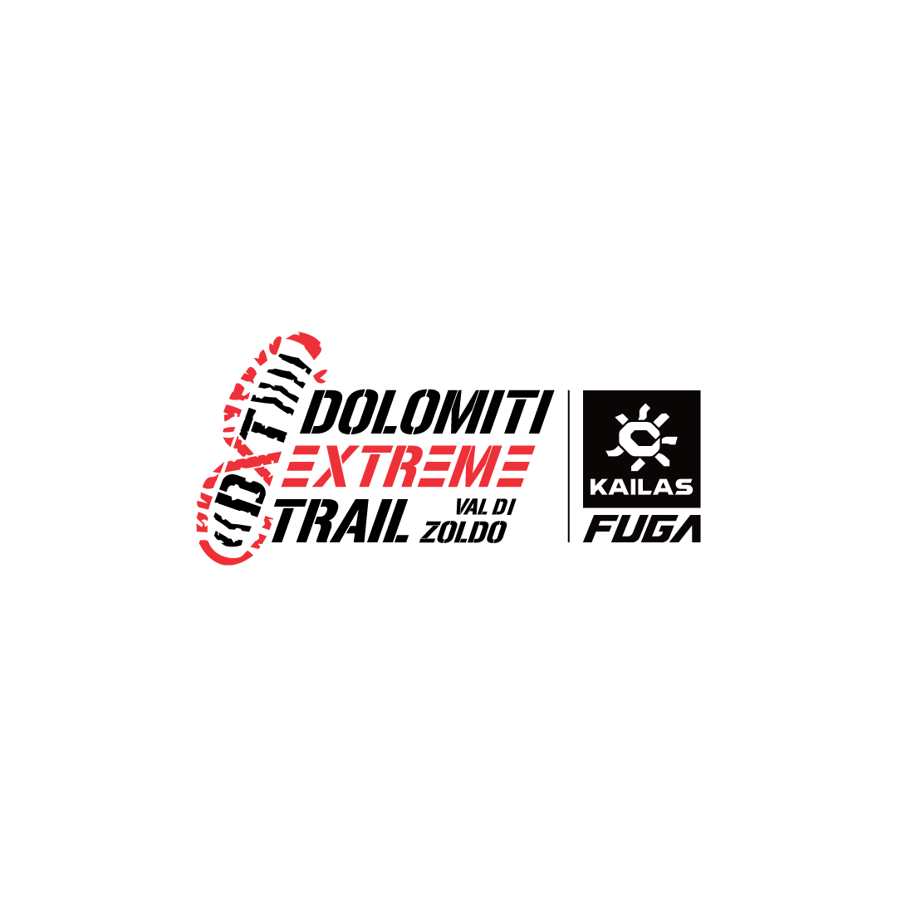The campaign, 'I do not throw my rubbish away' is promoted by the magazine Spirit Trail ([www.spiritotrail.it](http://www.spiritotrail.it/))